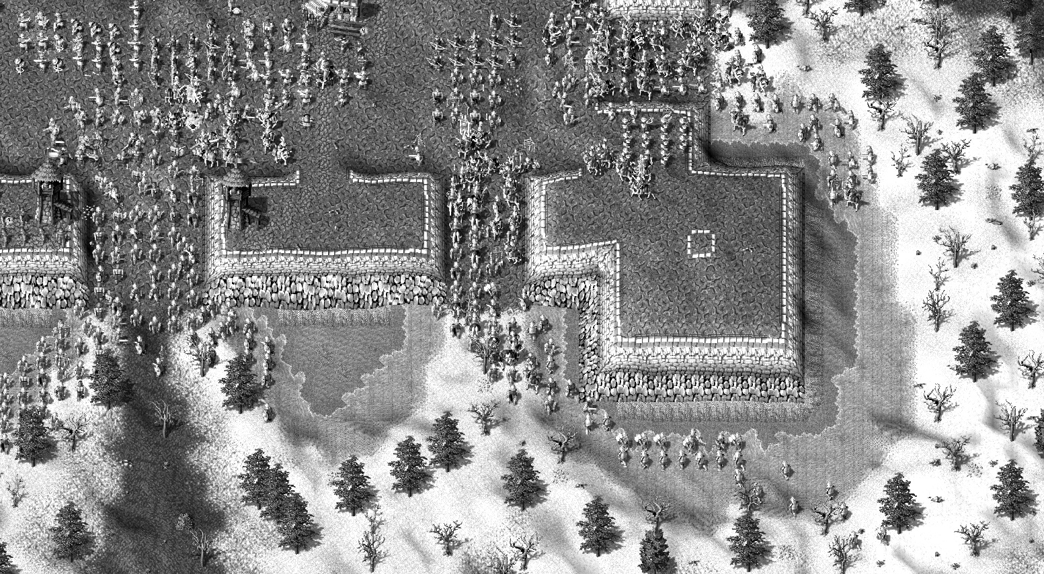







**Contents**

Description 3

Points and bonuses 4

Tips and tricks 8

What’s new 9

     9

     10

     11

     12

     13

# Description

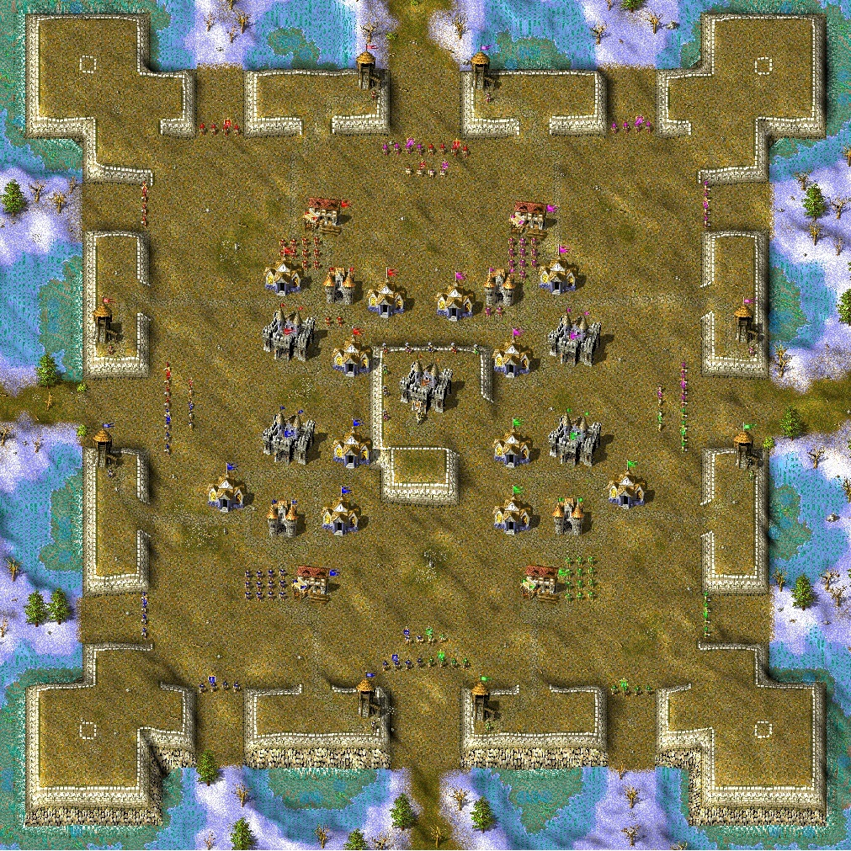

In this mission you should defend the Castle (your ally’s Barracks, and General - Knight - as well) and defeat 35 enemy attacks. Every next attack is stronger than previous. On last 4 waves AI will send extra ambush troops. You have a lot of weapons, but not so much gold and can't equip strong soldiers at start. You can unlock new soldiers by killing enemy troops.

Until 13th wave enemy will attack only central entrances on each side of the Castle. Some soldiers still can go to flanks, so be careful.

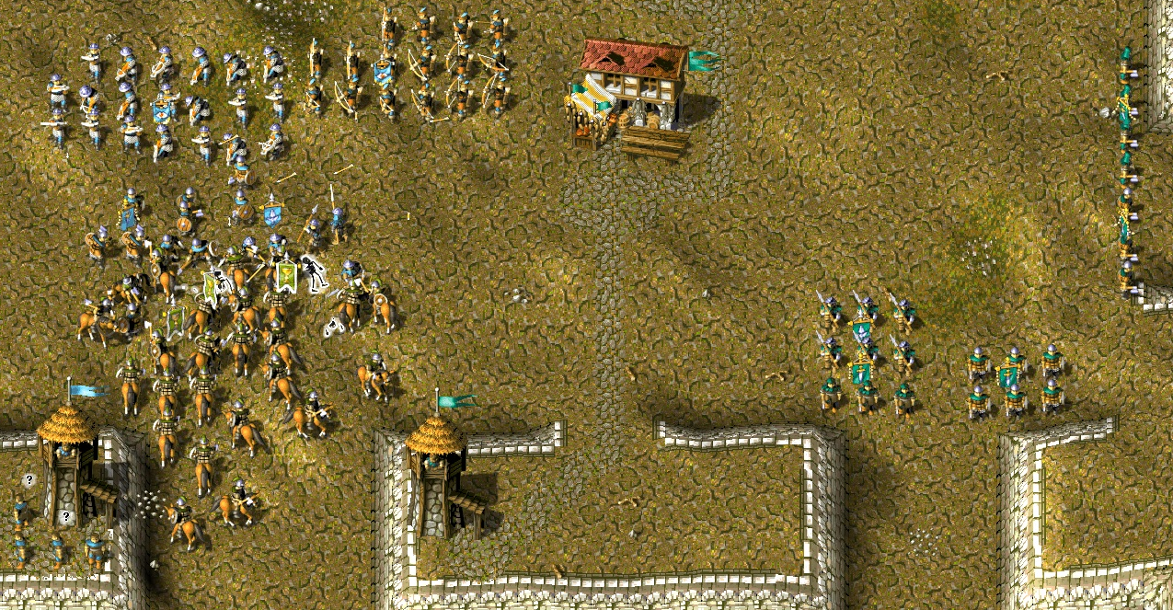

Later enemies will change their tactic and send more and more troops to attack flanks.

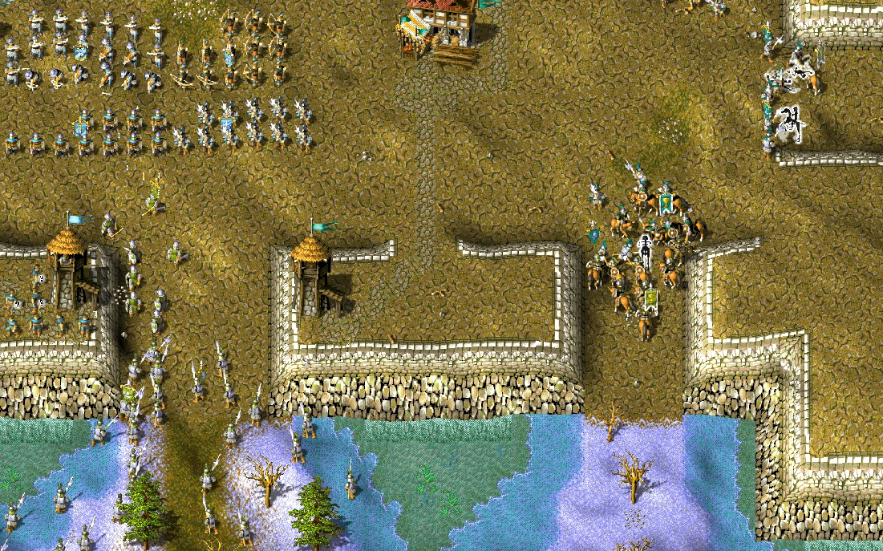

Each entrance should be well protected, and teamwork is very important here, it’s a key to victory. Any mistake can be fatal.

Players can build towers anywhere they want, inside the castle walls. 2 towers available at start, additional tower costs 50 gold. Enter ***/tower*** command into chat or enable Storehouse repair to buy a tower.

There are some bonuses and tricks which will help you ;)

# Points and bonuses

At start you can equip only militias. To equip stronger soldiers, you should get points by killing enemy units. Every killed enemy soldier gives one point. Certain number of points unlocks new soldiers. Here is unlock order for normal difficulty:

**50 points** - Lance Carrier

**100 points** - Axe Fighter

**160 points** - Bowman

**250 points** - Crossbowman

**400 points** - Pikeman

**500 points** - Scout

**700 points** - Sword Fighter

**1000 points** - Barbarian, Warrior

**1250 points** - Knight

**NOTE:** To equip Barbarians and Warriors, enable Barracks repair when you have at least 1000 points and equip militia. One Barbarian or Warrior will cost you 4 hand axes and one recruit.

Unlock order will be shown in the message when game starts. Costs are different for each difficulty level.

When you reach 18th wave, one of 9 bonuses will be activated:

* **Immediate Kill** - You have chances to kill enemy unit from one hit.
* **Double** - You have chances to get extra soldiers when equipping army.
* **New conscription** - 10-15 new recruits will join you when new wave is coming.
* **Reinforcement** - A random troop of 12-15 men will join you when new wave is coming.
* 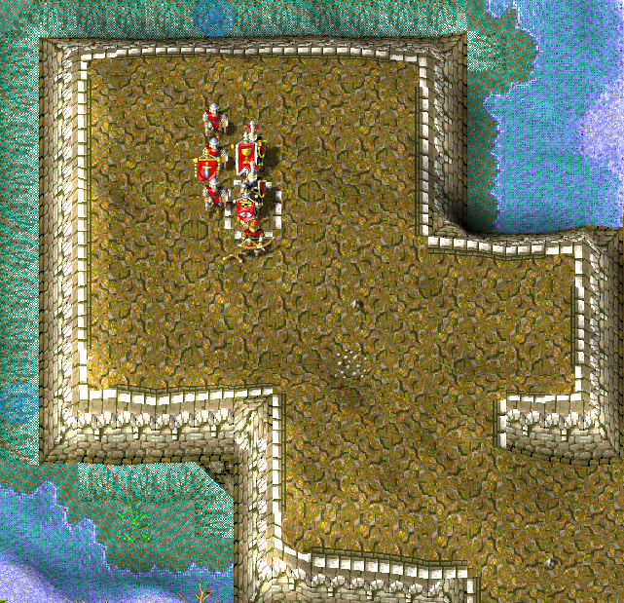**Reborn** - Your soldiers can reborn. Reborn soldiers will appear in the corner of castle walls:
* **Newborn Ally** - Enemy soldiers can reborn and fight on your side. Reborn soldiers will appear in the corner of castle walls.
* **Riffle Division** - You have chances to get extra ranged units when equipping melee (militias, axe fighters, sword fighters) units.
* **Retribution** -There's some chances that enemy soldiers dared to attack you will die immediately.
* **Reinforced Armor** -There’s some chances that your soldiers will not get any damage

**NOTE:** Bonus will be chosen randomly.

When you reach 26th wave, new bonus will be activated - **Rescue Squad**. With this bonus you can get reinforcement from the King immediately. To use this bonus, you should have less than 110 soldiers and less than 10 recruits. You can use it 4 times, every next usage is delayed for 1,5 minutes. To get it, enter ***/rescue*** command or place a road plan in special tile in the corner of castle walls:

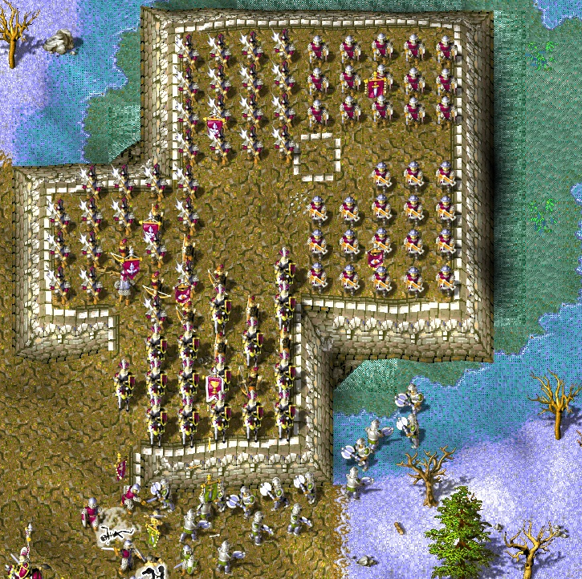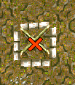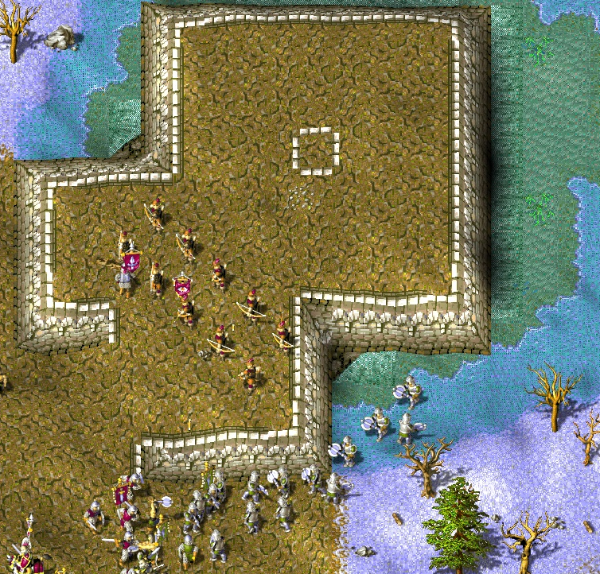

When you reach 31st wave, 4 more bonuses will be available: **Stone Wall**, **Moat**, **Drought** and **Poisoning**. 3 of them will be chosen for you randomly. You can activate them by placing a winefield plan in the tile near the special objects (objects will be placed on the wall near allied Barracks) or via console command - ***/wall***, ***/moat***, ***/drought***, ***/poison***. Every next bonuses usage is delayed for 3 minutes.

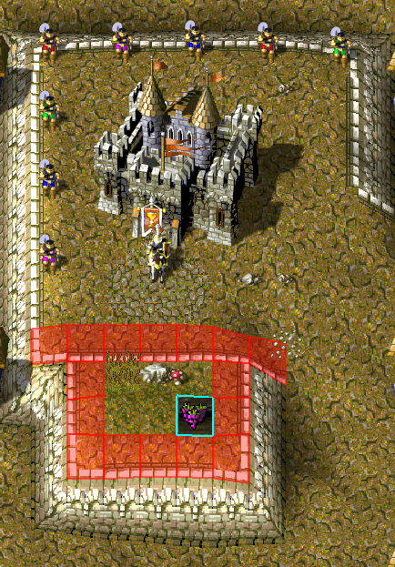

**Stone Wall** bonus will block allied Barracks entrances for 3 minutes. To use it, place winefield plan in the special tile next to Big Stone or use ***/wall*** command.

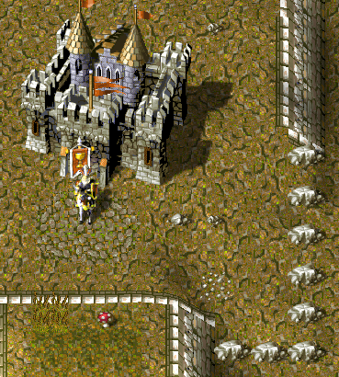

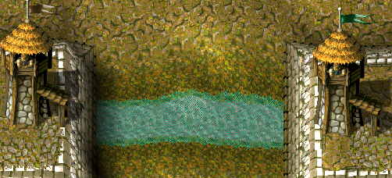**Moat** bonus will block 3-4 random Castle entrances by moats for 3 minutes. To use it, place winefield plan in the special tile next to Reed or use ***/moat*** command.

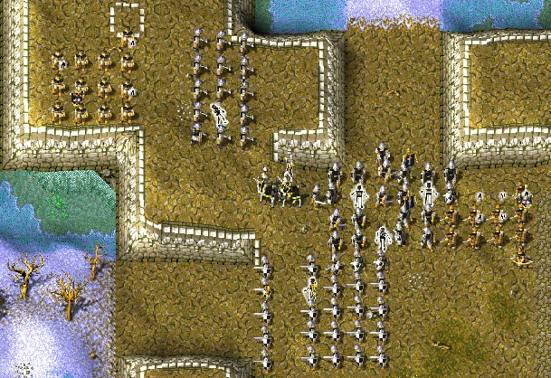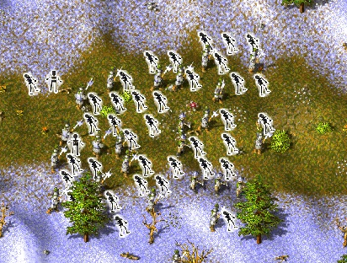**Poisoning** bonus will kill randomly 50-70% of enemy soldiers but also can kill some of your troops. To use it, place winefield plan in the special tile next to Red Mushroom or use ***/poison*** command.

**Drought** bonus will set hunger level of random 50-70% of enemy soldiers to critical but also can do this for some of your troops. To use it, place winefield plan in the special tile next to Cactus or use ***/drought*** command.

# Tips and tricks

* **Don’t waste gold!** You have not so much gold (12-20 chests per wave) and won’t need weak soldiers in the future. So, on first waves better equip 2-3 squads (enough to protect your entrances) and wait for stronger troops.
* **Arrange defense positions within the team at start!** The best way is to defend one side or one corner of the Castle (one middle and two flank entrances), for example:

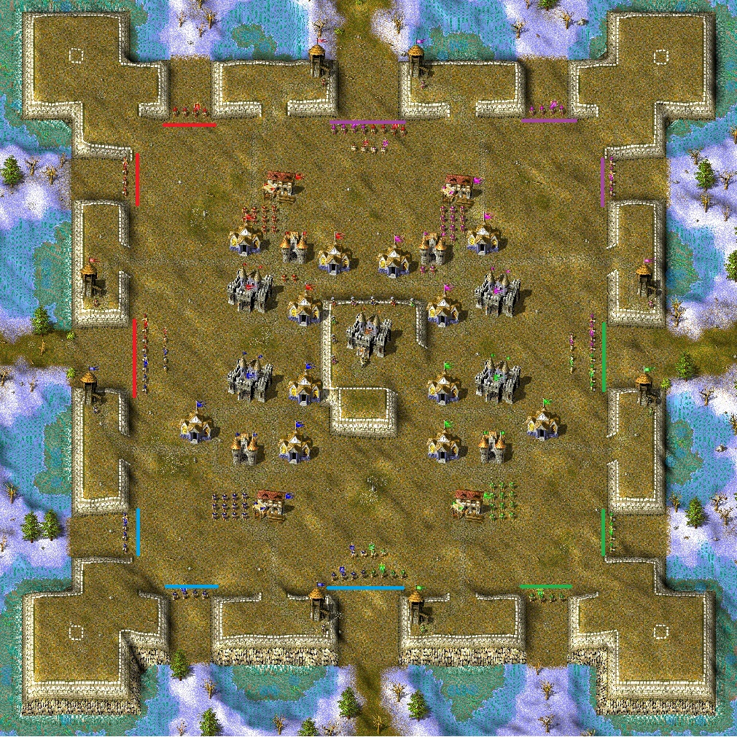

* **No need to send much soldiers to defend flanks until 13th wave**. Only some enemy soldiers could go there, so one small squad will be enough to kill them.
* **Check all defense positions** from time to time and help each other.
* **Use Hotkeys and Rally Point** for Barracks.
* **Check wave names.** They can help sometimes, tell which soldiers are coming.
* **To respawn your serfs,** place a field plan somewhere inside the Castle or use ***/serfs*** command
* **To buy a tower,** enter ***/tower*** command into chat or Enable storehouse repair and place a tower.
* **To show all available tips,** enter ***/help*** command into chat

# What’s new

##     

- Added 5 new waves

- Attacks are random since 16th wave now

- Added new random bonus - Retribution

- Added lategame bonuses - Stone Wall, Moat, Poisoning

- One more rescue squad available

- Bonuses rebalanced

- Disabled troops splitting abuse

- Players list sorted by points (not by locations)

- Added status strings (shows unlocked troops, used bonuses etc):

Player 1 <--- Unlocked Bowman!

- Tips for players during the game

- Rescue Squad reminder message

- Moved schools on bottom locations few tiles down for better army placement

- Autofeed for army every 20 minutes

- You can respawn your serfs by placing field plan inside the Castle

- Cover revealed areas outside the Castle with every new wave

- Minor bugfixes

- Balance things

##     

- Players have no towers at start, but can build 2 towers since 6th wave

- Scouts are available earlier than Pikemen. To equip Scouts you need 400 kills, to equip Pikemen you need 500 kills

- Added more horses into Barracks

- Added new lategame bonus - Drought

- Weak random flank attacks for waves 1-12

- Some balance things

- Minor bugfixes

##     

* Added difficulty levels: Easy, Normal, Hard. Difficulty multipliers: x0.8, x1, x1.2
* Towers are available on 2nd wave (easy), 5th wave (normal), 8th wave (hard). 3 towers available on easy difficulty
* Allow to buy extra towers (players can have 4 towers max)
* Revert Scout and Pikeman unlock order
* Unlock costs will be shown in the message when game starts
* More tips during the game
* Show game bonus and its chance
* New bonus - Reinforced Armor
* FOW will not cover the map on Easy difficulty
* Min troop members count depends on difficulty level. On normal level it’s 5 men, on easy 4, on hard 6
* Balance improvements
* Minor bugfixes

##     

* Enter /help command to show all available tips
* Message about reinforcement, when bonus “Reinforcement” is activated, to help players find their groups faster
* Improved script performance
* Increased start serfs count to 16
* Fixed double AI groups spawns on 26th wave
* Fixed tower placement
* Rogues should join closest group within 10 tiles. If closest group is not found, they try to go to rally point
* Fixed bonus “Double”, spawned extra units twice when equipping barbarians (extra militia + extra barbarian)
* Fixed various script warnings and crashes

##     

* Added console commands: /wall, /moat, /poison, /drought for late bonuses; /rescue for rescue squad; /serfs to respawn died serfs
* Removed/replaced some wrong objects on the map
* Fixed some broken tiles